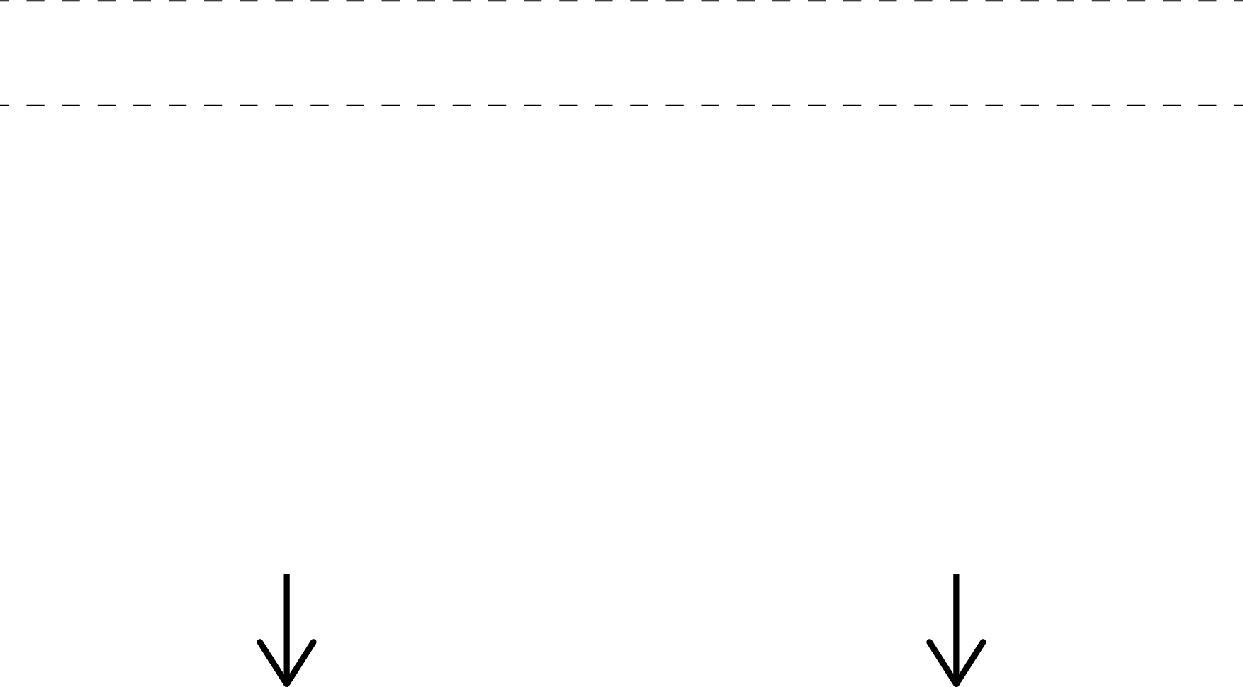

Answer B

Answer A

Type your question here